Deadly ECG Summary Sheet

- Decompensated Atrial Fib. Don’t go trying to control the rate right away, get the BP up! Phenylephrine.

- Profound Bradycardia. Don’t just treat the brady, look for causes. Do electrolytes stat! Think of meds/overdose as a cause.

- V Fib/Pulseless V Tach. You better know this cold!

- (a) Upright R and T waves in aVR lead.
Usually waves are all negative in aVR.
Wide QRS with prominent R – think TCA overdose.
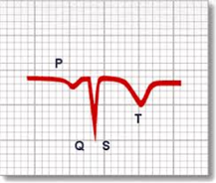 Normally all waves are negative
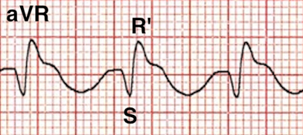 TCA Overdose. 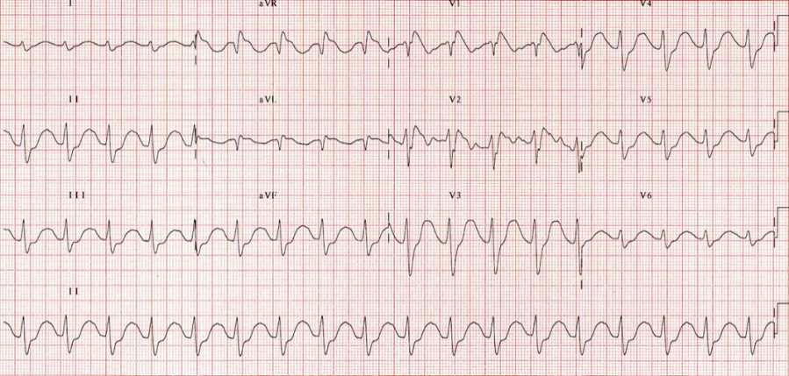

(b) ST elevation in aVR of > 0.5 mm or > ST elevation in V1 = LAD occlusion or 3 vessel disease.

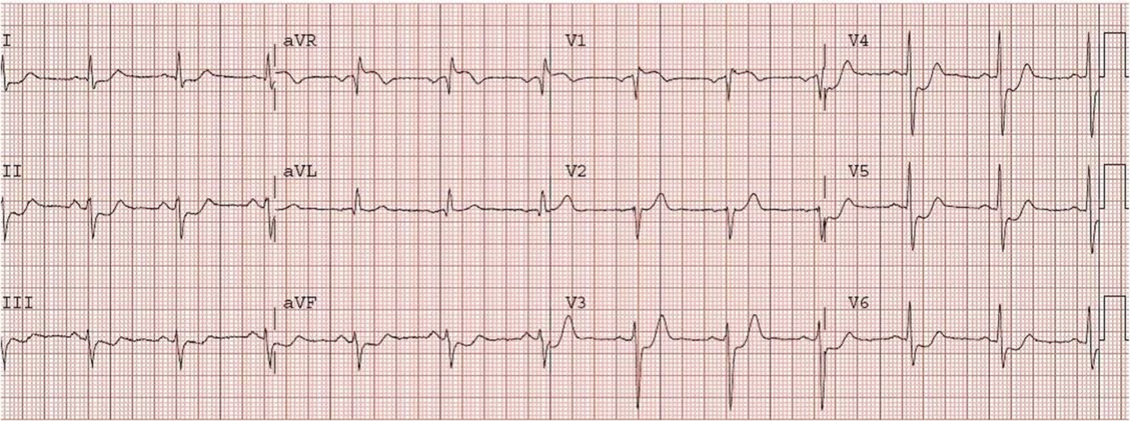

- QT interval – prolonged if QTc > 440 ms in men and > 460 ms in women.
QTc> 500 ms is associated with risk of Torsade’s de pointes.
(QTs < 350 ms (congenital) ~ PAT, V Fib and sudden cardiac death)
Causes: Hypokalemia, Hypocalcemia, Hypomagnesemia, Antipsychotics, TCA, most antidepressants, antihistamines, IV amiodarone, Increased ICP….
Trt: Usually resolve spontaneously, otherwise MgSo4 1-4 gm IV and then treat underlying cause.

- Electrical Alternans = large pericardial effusion
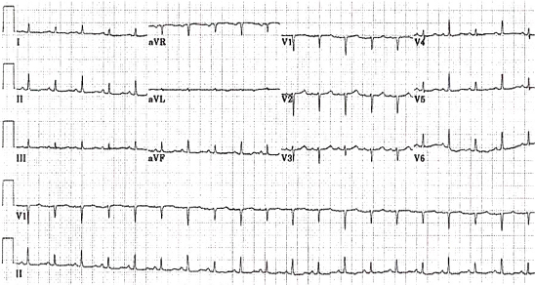
Pericarditis characteristics:
- Electrical Alternans – only occurs in about 30% cases
- Tachycardia
- Low Voltage – QRS size in I+II+III < 15 mm OR QRS V1+V2+V3 < 30 mm
- Cardiomegaly on CXR
- PCE on POCUS – the most sensitive test!

- Scarbossa Criteria
- ST elevation > 1mm in the same direction with the QRS (concordant)
- ST depression > 1mm in V1, 2, 3.
- ST elevation > 5mm in opposite direction of QRS (discordant)
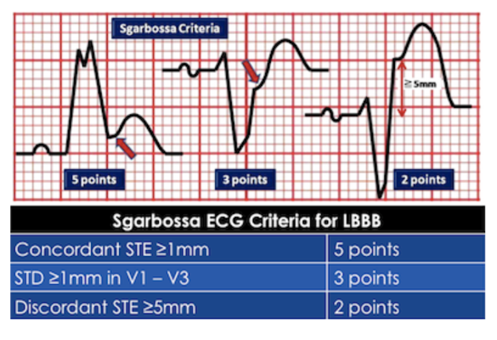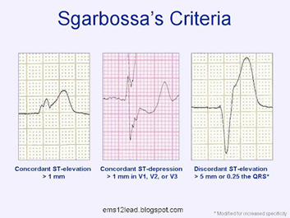

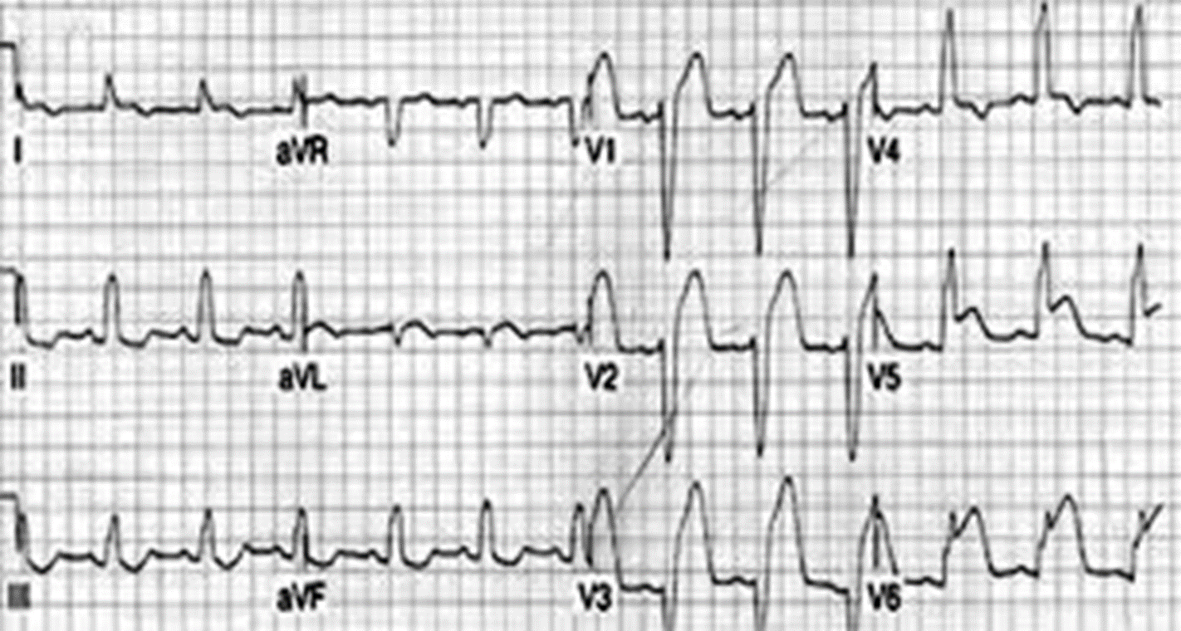
ST elevation V1 > 5 mm and ST elevation V5 -6

- Brugada sign = Coved ST segment > 2mm in V1-3
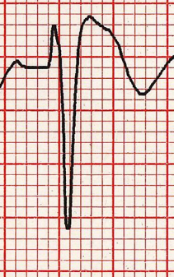
Brugada Syndrome = Brugada sign with documented VF, Polymorphic VT, family hx sudden death
< age 45, Brugada sign in family members, inducible VT with electrical stimulation, syncope, nocturnal agonal respirations.

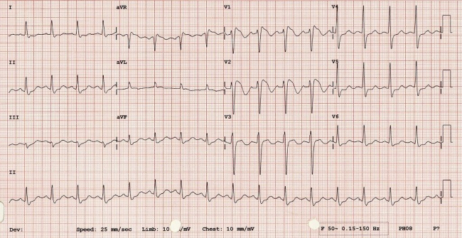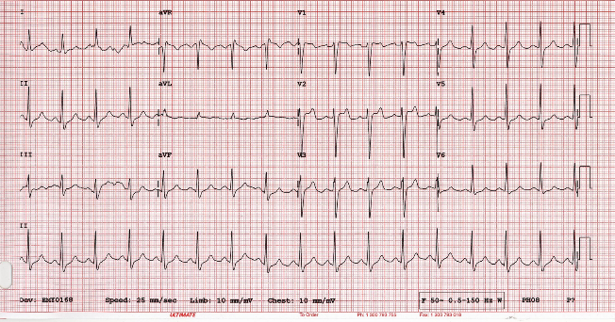

- Wellen’s Sign = deeply inverted T waves in V 2-3 = LAD stenosis
(no Q waves, no ST elevation but hx of angina)
Do NOT do stress test on Wellen’s as they may have sudden cardiac arrest. Need PCI.
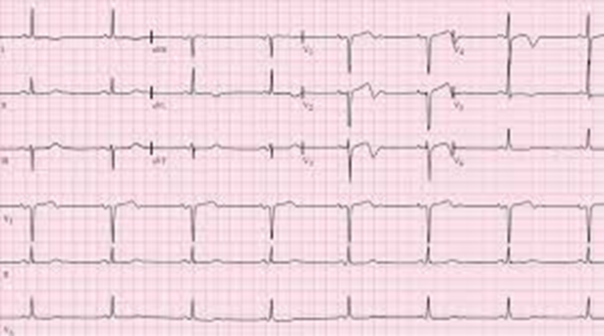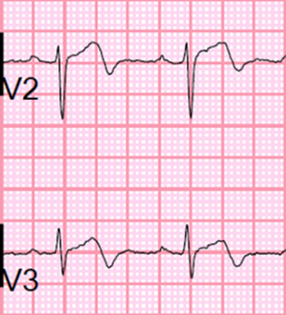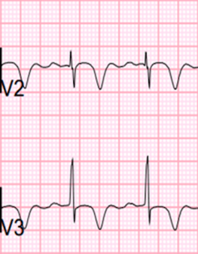
Pts can go from transient STEMI to Wellen’s sign and back to STEMI as LAD occludes, re-perfuses, then occludes again.

- De Winter’s sign = ST depression with upright T waves in anterior leads (2% LAD occlusion)
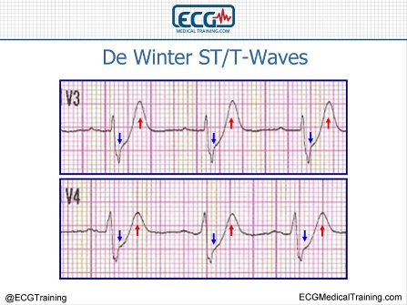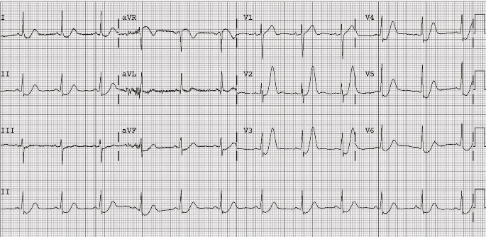

- AV block: 2nd Degree (Mobitz Type II)
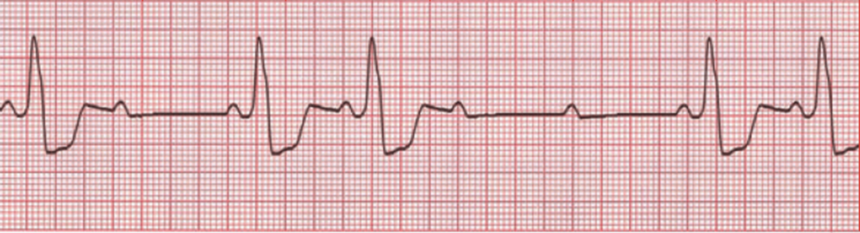
Admit and be aware may need temporary pacemaker backup.

- Hypertrophic Cardiomyopathy (HOC = IHSS, HCOM)
LVH and deep narrow Q waves in I, aVL, V5-6
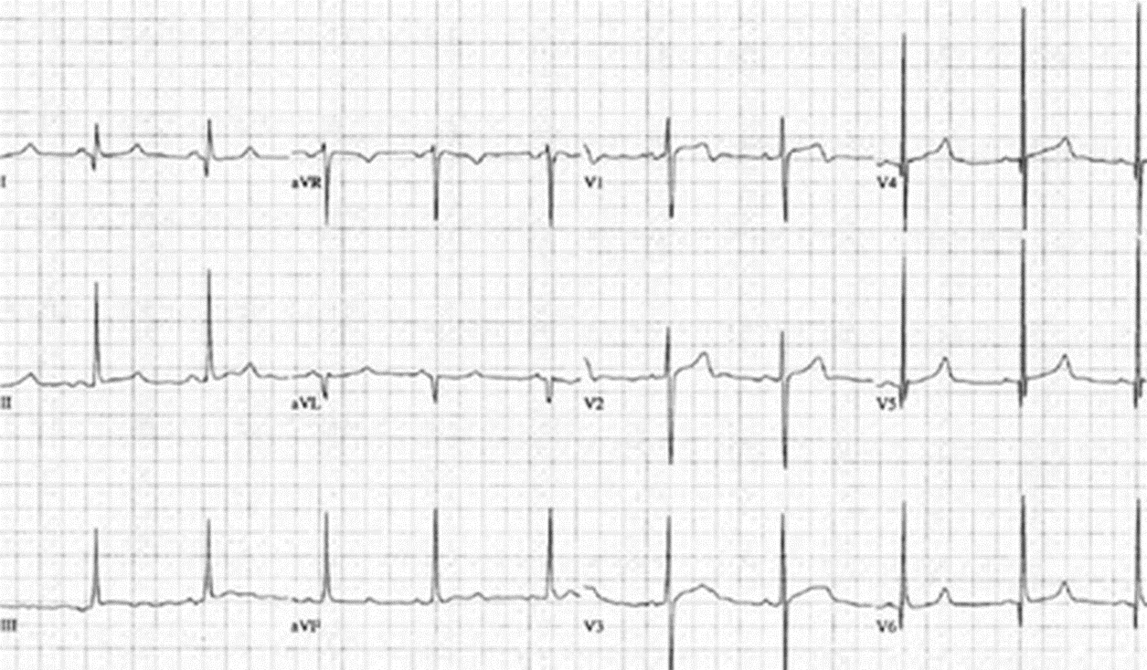

- Wolff-Parkinson-White
Broad QRS with slurred upstroke (Delta Waves), Dominant R wave in V1, Tall R wave and inverted T waves in V1-3 (mimic RVH)
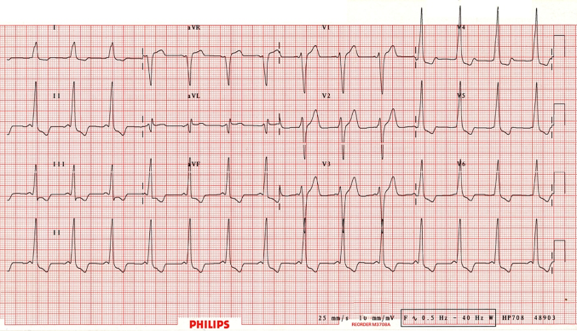

- aVL – ST depression
Down-sloping ST in aVL is suspicious of inferior ischemia or impending MI.
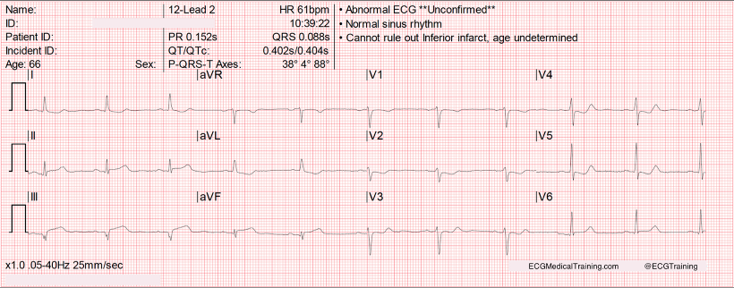
ST depression/inversion aVL = ischemia
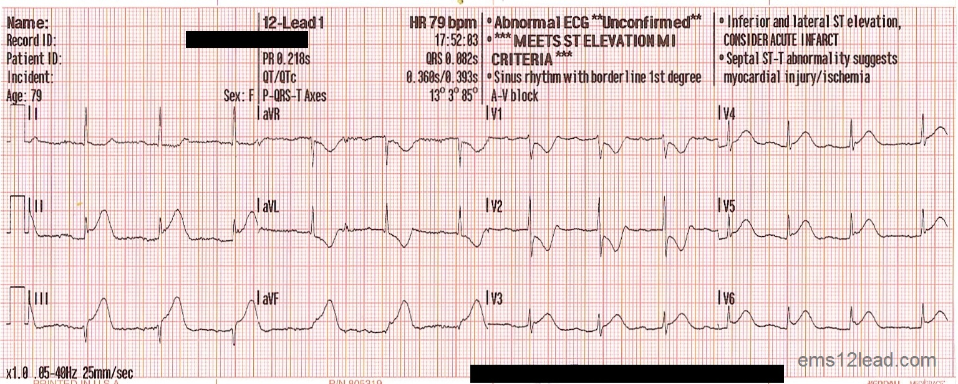
Full inferior MI with aVL ST depression and T wave inversion.

- BER (Benign Early Repolarization)
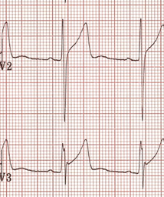
Widespread concave ST elevation in V2-5 found primarily in fit young males.
- notching or slurring of J point,
- concave ST elevation
- no reciprocal St depression elsewhere
- can have ‘fish hook’ appearance. (best in V4)

